

|  |
| --- |
| Tours & Travel management system |

Table of Contents

*Group Members:*

Amrita Dey, B.P. Poddar,171150110011

Debduti Mondal, B.P. Poddar,181150120006

Apurba Paul, B.P. Poddar,171150110202

• Acknowledgement

• Project Objective

• Project Scope

• Requirement Specification

• Database Design

• Application Work Flow Diagram

• Screenshots

• Future Scope of Improvements

• Code

Acknowledgement

We would like to express our sincere thanks and gratitude to Mr. Titas Roy Chowdhury sir for sharing his knowledge with us, his guidance throughout our training.Without his motivation, constant support we couldn’t complete this project.

We would like to thank Globsyn team for this Knowledge-packed industrial training and the wonderful community.

Last but not the least we would like to express our love, respect, gratitude to our parents.

Project Objective

❖It is basically a desktop application.

❖It is designed for one particular administrator.

❖Through this system admin can manage the customer & also can keep the information of hotel availability.

❖From this system Admin can view daily, weekly and monthly report.

❖This system is developed for admin who can add, delete, edit and view the data related to places, travels, bookings from this system.

Project Scope

This “Tours & Travel Management System” has been designed to computerize the following functions that are performed by the system:

* Customer details function
* Room details function
* Opening a new room
* Sign up of new customer
* Booking details function
* Opening a new hotel
* Hotel details function
* Check in function
* Room assigning to customer’s need
* Room occupancy details functions

Requirement Specification

* It is a desktop application so data will be entered from the user side.
* The minimum requirement to access the application is a normal desktop with JDK installation. The memory requirement is very minimum.
* The customers can book hotel in advance.
* If a customer is already contact with us then the details of him/her is already in our database.
* The data are well organised, well maintained and easy to access.

Software requirement:Windows 7 or above, Linux, Mac OS X or above and Jdk 11 or above

hardware requirement:Processor-Intel dual core or above,

Amd A6 or above.

Ram – 4gb or more

Storage – 128gb

File system

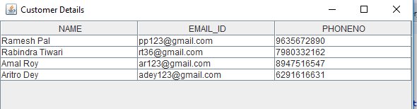

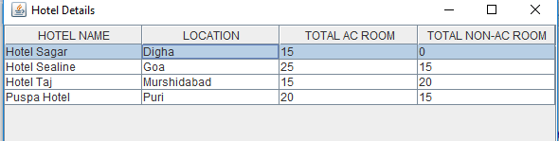

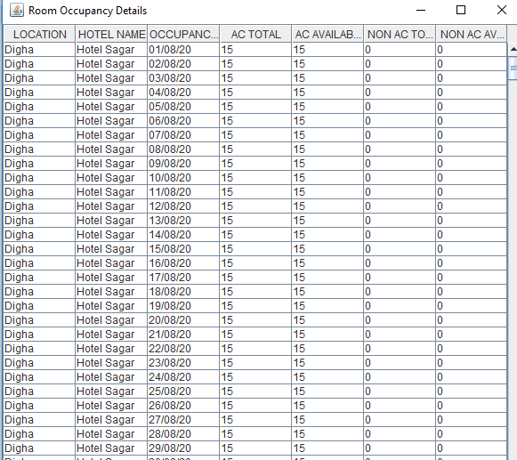

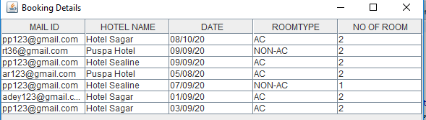

Application work flow

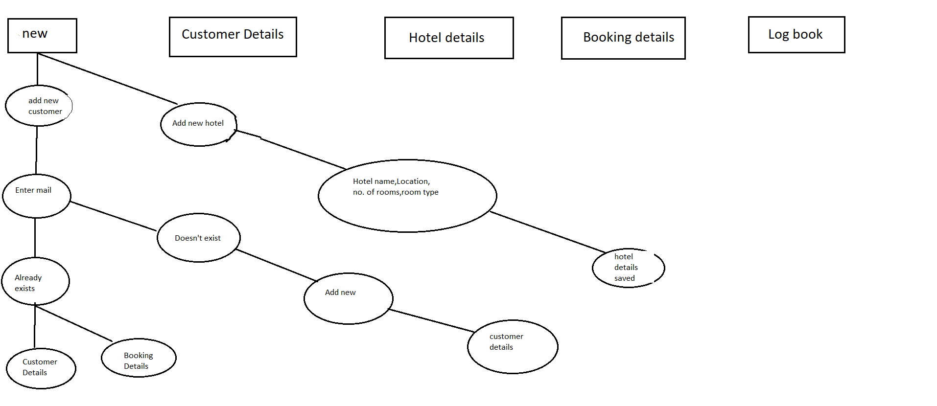

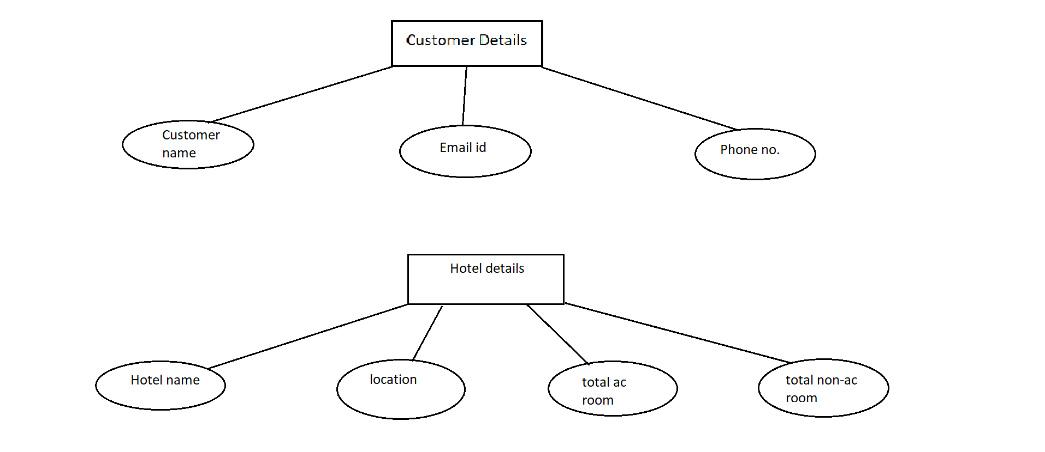

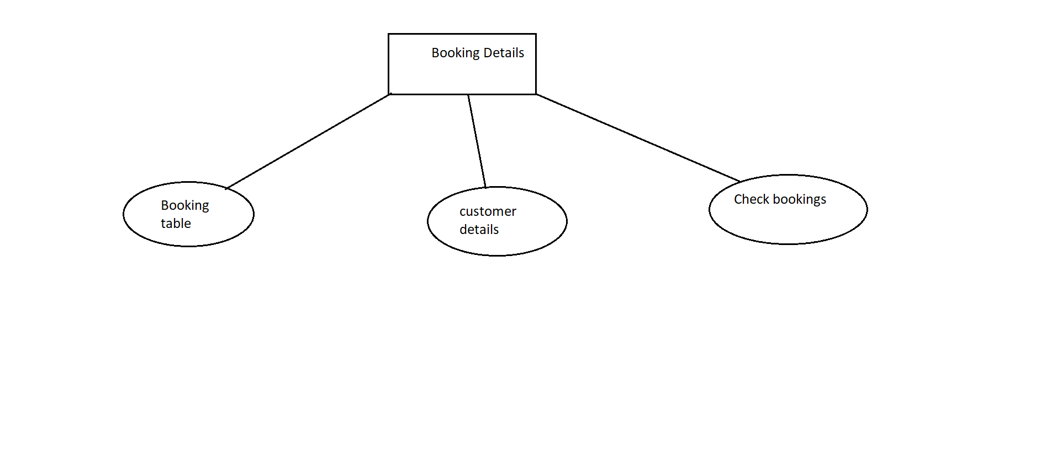

Screenshots

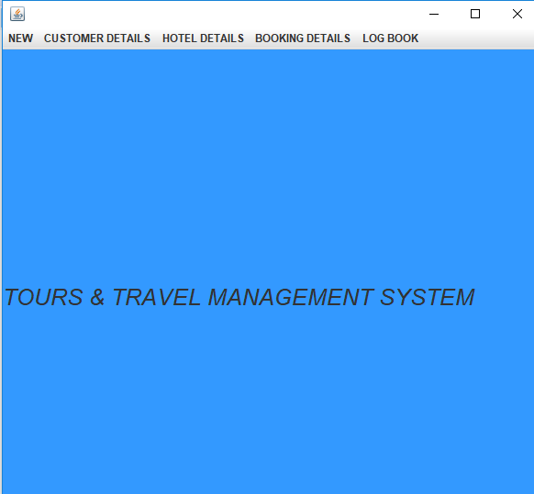

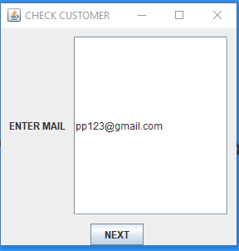

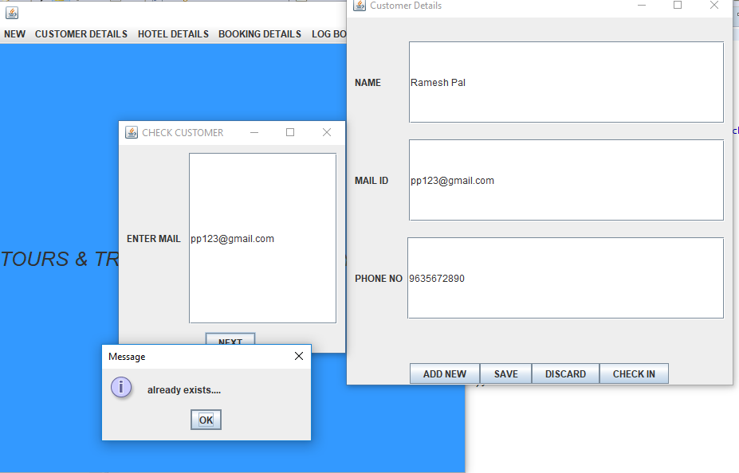

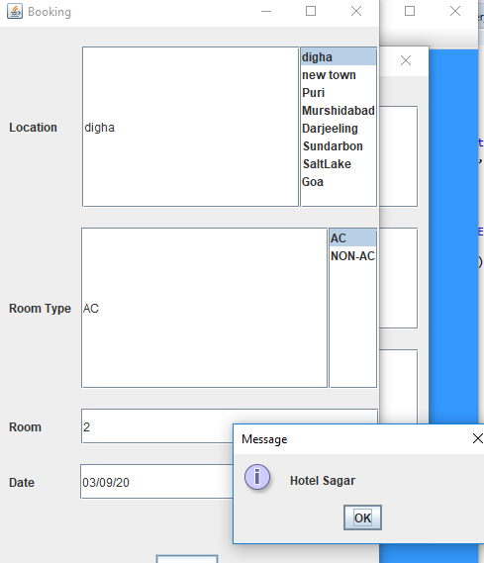

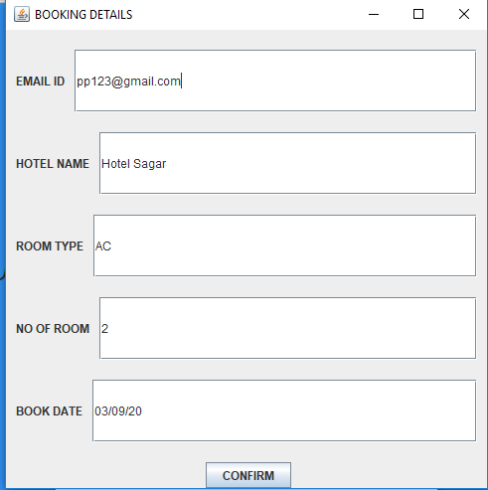

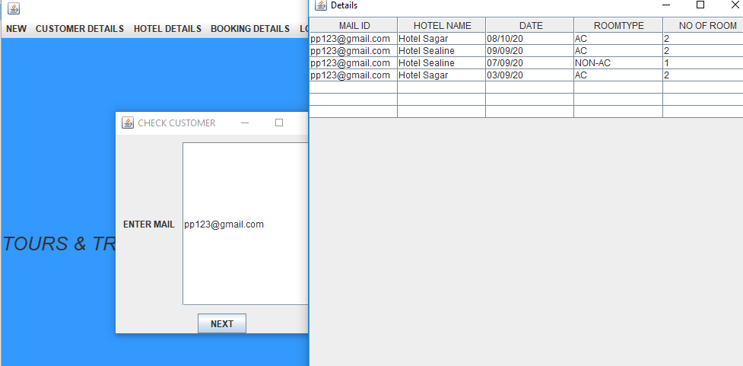

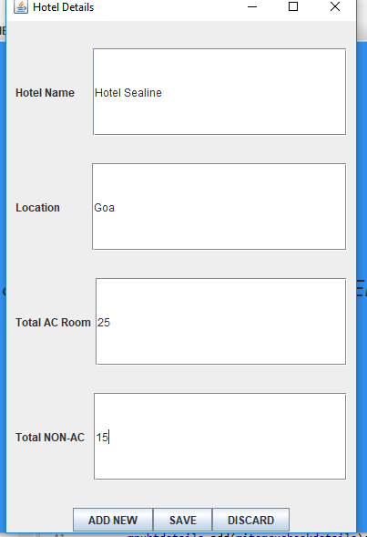

Future Scope of Improvements

❖After booking a confirmation mail should be included to the customer.

❖Keep a route map.

❖Further more hotels can be added in various location.

❖The booking process can be developed in case of more than one day booking.

Code

1. package grp4proj;

import java.awt.Color;

import java.awt.Font;

import javax.swing.*;

public class MenuFrame extends JFrame {

private JLabel lblname;

private JMenu mnunew, mnubtdetails, mnuhtdetails, mnuctdetails, mnudtdetails;

private JMenuItem mitemCNew, mitemhnew, mitemhtdetails, mitemcdetails,mitembookingdetails,mitembookingcheck,mitemroomdetails;

private JMenuBar bar;

public MenuFrame() {

lblname=new JLabel("TOURS & TRAVEL MANAGEMENT SYSTEM");

getContentPane().add(lblname);

lblname.setFont(new Font("Cracked", Font.ITALIC,25));

bar = new JMenuBar();

mnunew = new JMenu("NEW");

mnuctdetails = new JMenu("CUSTOMER DETAILS");

mnuhtdetails = new JMenu("HOTEL DETAILS");

mnubtdetails = new JMenu("BOOKING DETAILS");

mnudtdetails = new JMenu("LOG BOOK");

mitemCNew = new JMenuItem("ADD NEW CUSTOMER");

mitemhnew = new JMenuItem("ADD NEW HOTEL");

mitemhtdetails = new JMenuItem("HOTEL DETAILS");

mitemcdetails = new JMenuItem("CUSTOMER DETAILS");

mitembookingdetails=new JMenuItem("BOOKING TABLE");

mitembookingcheck=new JMenuItem("CHECK BOOKING");

mitemroomdetails=new JMenuItem("ROOM DETAILS");

mnunew.add(mitemCNew);

mnunew.add(mitemhnew);

mnuctdetails.add(mitemcdetails);

mnuhtdetails.add(mitemhtdetails);

mnubtdetails.add(mitembookingdetails);

mnubtdetails.add(mitembookingcheck);

mnudtdetails.add(mitemroomdetails);

mitemCNew.addActionListener(e -> {

new CheckEmail();

});

mitemhnew.addActionListener(e -> {

new DataEntryHotel();

});

mitemcdetails.addActionListener(e -> {

new CustomerListFrame();

});

mitemhtdetails.addActionListener(e -> {

new HotelListFrame();

});

mitembookingdetails.addActionListener(e->{

new BookingListFrame();

});

mitembookingcheck.addActionListener(e->{

new Checkbooking();

});

mitemroomdetails.addActionListener(e->{

new RoomOccupancyListFrame();

});

bar.add(mnunew);

bar.add(mnuctdetails);

bar.add(mnuhtdetails);

bar.add(mnubtdetails);

bar.add(mnudtdetails);

setJMenuBar(bar);

setSize(600,600);

getContentPane().setBackground(new Color(51, 153, 255));

setDefaultCloseOperation(JFrame.EXIT_ON_CLOSE);

setLocationRelativeTo(null);

setVisible(true);

}

public static void main(String[] args) {

MenuFrame mf = new MenuFrame();

}

}

=====================================================================================

2. package grp4proj;

import java.io.Serializable;

public class Hotel implements Serializable {

private String name;

private String location;

private int total_acrooms;

private int total_nonacrooms;

public Hotel() {

super();

}

public Hotel(String name,String location, int total_acrooms, int total_nonacrooms) {

this.name = name;

this.location = location;

this.total_acrooms = total_acrooms;

this.total_nonacrooms = total_nonacrooms;

}

public String getName() {

return name;

}

public void setName(String name) {

this.name = name;

}

public String getLocation() {

return location;

}

public void setLocation() {

this.location = location;

}

public int getTotal_acrooms() {

return total_acrooms;

}

public void setTotal_acrooms(int total_acrooms) {

this.total_acrooms = total_acrooms;

}

public int getTotal_nonacrooms() {

return total_nonacrooms;

}

public void setTotal_nonacrooms(int total_nonacrooms) {

this.total_nonacrooms = total_nonacrooms;

}

}

=================================================================================

3. package grp4proj;

import java.awt.Color;

import java.awt.Dimension;

import java.io.*;

import java.util.*;

import javax.swing.*;

public class DataEntryHotel extends JFrame{

JLabel lblname,lbltype,lblloc,lbltotal,lblnonac;

JTextField txtname,txttype,txtloc,txtactotal,txtnonactotal;

JButton btnnew,btnsave,btndiscard;

private List<Hotel> list=null;

public DataEntryHotel() {

super("Hotel Details");

Box mainbox=Box.createVerticalBox();

Box b1=Box.createHorizontalBox();

lblname=new JLabel("Hotel Name");

txtname=new JTextField(10);

b1.add(Box.createRigidArea(new Dimension(10,0)));

b1.add(lblname);

b1.add(Box.createRigidArea(new Dimension(20,0)));

b1.add(txtname);

b1.add(Box.createRigidArea(new Dimension(10,0)));

Box b3=Box.createHorizontalBox();

lblloc=new JLabel("Location");

txtloc=new JTextField(10);

b3.add(Box.createRigidArea(new Dimension(10,0)));

b3.add(lblloc);

b3.add(Box.createRigidArea(new Dimension(35,0)));

b3.add(txtloc);

b3.add(Box.createRigidArea(new Dimension(10,0)));

Box b4=Box.createHorizontalBox();

lbltotal=new JLabel("Total AC Room");

txtactotal=new JTextField(10);

b4.add(Box.createRigidArea(new Dimension(10,0)));

b4.add(lbltotal);

b4.add(Box.createRigidArea(new Dimension(5,0)));

b4.add(txtactotal);

b4.add(Box.createRigidArea(new Dimension(10,0)));

Box b5=Box.createHorizontalBox();

lblnonac=new JLabel("Total NON-AC");

txtnonactotal=new JTextField(10);

b5.add(Box.createRigidArea(new Dimension(10,0)));

b5.add(lblnonac);

b5.add(Box.createRigidArea(new Dimension(10,0)));

b5.add(txtnonactotal);

b5.add(Box.createRigidArea(new Dimension(10,0)));

Box b7=Box.createHorizontalBox();

btnnew=new JButton("ADD NEW");

btnsave=new JButton("SAVE");

btndiscard=new JButton("DISCARD");

b7.add(btnnew);

b7.add(btnsave);

b7.add(btndiscard);

mainbox.add(Box.createRigidArea(new Dimension(0,30)));

mainbox.add(b1);

mainbox.add(Box.createRigidArea(new Dimension(0,30)));

mainbox.add(b3);

mainbox.add(Box.createRigidArea(new Dimension(0,30)));

mainbox.add(b4);

mainbox.add(Box.createRigidArea(new Dimension(0,30)));

mainbox.add(b5);

mainbox.add(Box.createRigidArea(new Dimension(0,30)));

mainbox.add(b7);

add(mainbox);

btnnew.addActionListener(e->{

String hnamestr=txtname.getText().trim();

String locstr=txtloc.getText().trim();

String totalacroomstr=txtactotal.getText().trim();

String totalnonacstr=txtnonactotal.getText().trim();

int totalac=Integer.parseInt(totalacroomstr);

int totalnonac=Integer.parseInt(totalnonacstr);

Hotel h=new Hotel(hnamestr,locstr,totalac,totalnonac);

list.add(h);

txtname.setText("");

txtloc.setText("");

txtactotal.setText("");

txtnonactotal.setText("");

});

btnsave.addActionListener(e->{

if(list!=null && list.size()!=0) {

DBManager_hotel.saveHotelData(list);

JOptionPane.showMessageDialog(DataEntryHotel.this,"Hotel record saved...:)");

}

});

setSize(400, 600);

setDefaultCloseOperation(JFrame.HIDE_ON_CLOSE);

setLocationRelativeTo(null);

setVisible(true);

list=DBManager_hotel.loadsHoteldata();

if(list==null) {

list=new ArrayList<>();

}

}

public static void main(String[] args) {

// TODO Auto-generated method stub

DataEntryHotel dh=new DataEntryHotel();

new GenerateHotel();

}

}

=====================================================================================

4. package grp4proj;

import java.io.*;

import java.util.*;

public class DBManager_hotel {

public static List<Hotel> loadsHoteldata() {

List<Hotel> list = null;

ObjectInputStream os = null;

FileInputStream fs = null;

try {

fs = new FileInputStream("hoteldetails.dat");

os = new ObjectInputStream(fs);

list = (List<Hotel>) os.readObject();

} catch (FileNotFoundException e) {

} catch (IOException e) {

} catch (ClassNotFoundException e) {

} finally {

try {

if (os != null)

os.close();

if (fs != null)

fs.close();

} catch (IOException e) {

// TODO Auto-generated catch block

e.printStackTrace();

}

}

return list;

}

public static void saveHotelData(List<Hotel> list) {

ObjectOutputStream os = null;

try {

os = new ObjectOutputStream(new FileOutputStream("hoteldetails.dat"));

if (list != null && list.size() != 0)

os.writeObject(list);

} catch (IOException e) {

// TODO Auto-generated catch block

e.printStackTrace();

} finally {

try {

os.close();

} catch (IOException e) {

// TODO Auto-generated catch block

e.printStackTrace();

}

}

}

public static List<RoomOccupancy> loadsRoomOccupancydata() {

List<RoomOccupancy> list = null;

ObjectInputStream os = null;

FileInputStream fs = null;

try {

fs = new FileInputStream("roomoccupancy.dat");

os = new ObjectInputStream(fs);

list = (List<RoomOccupancy>) os.readObject();

} catch (FileNotFoundException e) {

} catch (IOException e) {

} catch (ClassNotFoundException e) {

} finally {

try {

if (os != null)

os.close();

if (fs != null)

fs.close();

} catch (IOException e) {

// TODO Auto-generated catch block

e.printStackTrace();

}

}

return list;

}

public static void saveRoomOccupancyData(List<RoomOccupancy> list) {

ObjectOutputStream os=null;

try {

os=new ObjectOutputStream(new FileOutputStream("roomoccupancy.dat"));

if(list!=null && list.size()!=0) {

os.writeObject(list);

}

} catch (IOException e) {

// TODO Auto-generated catch block

e.printStackTrace();

}finally {

try {

os.close();

} catch (IOException e) {

// TODO Auto-generated catch block

e.printStackTrace();

}

}

}

}

5. package grp4proj;

import java.awt.Color;

import java.util.ArrayList;

import java.util.List;

import javax.swing.JFrame;

import javax.swing.JScrollPane;

import javax.swing.JTable;

public class HotelListFrame extends JFrame{

private JTable tblHotelList;

private String data[][];

private String[] colnames= {"HOTEL NAME","LOCATION","TOTAL AC ROOM","TOTAL NON-AC ROOM"};

private List<Hotel> list=null;

public HotelListFrame() {

// TODO Auto-generated constructor stub

super("Hotel Details");

list=DBManager_hotel.loadsHoteldata();

// creating 2d data array from list

String data[][]=new String[list.size()][4];

int row=0;

for(Hotel h:list) {

data[row][0]=h.getName();

data[row][1]=h.getLocation();

data[row][2]=String.valueOf(h.getTotal_acrooms());

data[row][3]=String.valueOf(h.getTotal_nonacrooms());

row++;

}

tblHotelList=new JTable(data, colnames);

add(new JScrollPane(tblHotelList));

setSize(600,600);

getContentPane().setBackground(new Color(51, 153, 255));

setDefaultCloseOperation(JFrame.HIDE_ON_CLOSE);

setLocationRelativeTo(null);

setVisible(true);

}

public static void main(String[] args) {

// TODO Auto-generated method stub

HotelListFrame hf=new HotelListFrame();

}

}

6. package grp4proj;

import java.io.Serializable;

public class Customer implements Serializable{

private String name;

private String email;

private String phnno;

public Customer(String name, String email, String phnno) {

this.name = name;

this.email = email;

this.phnno = phnno;

}

public Customer() {

super();

}

public String getName() {

return name;

}

public void setName(String name) {

this.name = name;

}

public String getEmail() {

return email;

}

public void setEmail(String email) {

this.email = email;

}

public String getPhnno() {

return phnno;

}

public void setPhnno(String phnno) {

this.phnno = phnno;

}

}

7. package grp4proj;

import java.awt.Color;

import java.awt.Dimension;

import java.io.FileNotFoundException;

import java.io.FileOutputStream;

import java.io.IOException;

import java.io.ObjectOutputStream;

import javax.swing.Box;

import javax.swing.JButton;

import javax.swing.JFrame;

import javax.swing.JLabel;

import javax.swing.JOptionPane;

import javax.swing.JTextField;

import java.util.*;

public class DataEntryCustomer extends JFrame{

private JLabel lblname,lblphnno,lblemailid;

private JTextField txtname,txtphnno,txtemailid;

private JButton btnsave,btnnew,btndiscard,btncheckin;

private List<Customer> list=null;

String m;

public DataEntryCustomer(Customer c) {

this();

txtname.setText(c.getName());

txtemailid.setText(c.getEmail());

txtphnno.setText(c.getPhnno());

m=c.getEmail();

}

public DataEntryCustomer() {

super("Customer Details");

Box mainbox=Box.createVerticalBox();

lblname=new JLabel("NAME");

txtname=new JTextField(10);

Box b1=Box.createHorizontalBox();

b1.add(Box.createRigidArea(new Dimension(10,0)));

b1.add(lblname);

b1.add(Box.createRigidArea(new Dimension(35,0)));

b1.add(txtname);

b1.add(Box.createRigidArea(new Dimension(10,0)));

lblemailid=new JLabel("MAIL ID");

txtemailid=new JTextField(10);

Box b2=Box.createHorizontalBox();

b2.add(Box.createRigidArea(new Dimension(10,0)));

b2.add(lblemailid);

b2.add(Box.createRigidArea(new Dimension(26,0)));

b2.add(txtemailid);

b2.add(Box.createRigidArea(new Dimension(10,0)));

Box b3=Box.createHorizontalBox();

lblphnno=new JLabel("PHONE NO");

txtphnno=new JTextField(10);

b3.add(Box.createRigidArea(new Dimension(10,0)));

b3.add(lblphnno);

b3.add(Box.createRigidArea(new Dimension(6,0)));

b3.add(txtphnno);

b3.add(Box.createRigidArea(new Dimension(10,0)));

Box b4=Box.createHorizontalBox();

btnnew=new JButton("ADD NEW");

btnsave=new JButton("SAVE");

btndiscard=new JButton("DISCARD");

btncheckin=new JButton("CHECK IN");

b4.add(btnnew);

b4.add(btnsave);

b4.add(btndiscard);

b4.add(btncheckin);

mainbox.add(Box.createRigidArea(new Dimension(0,30)));

mainbox.add(b1);

mainbox.add(Box.createRigidArea(new Dimension(0,20)));

mainbox.add(b2);

mainbox.add(Box.createRigidArea(new Dimension(0,20)));

mainbox.add(b3);

mainbox.add(Box.createRigidArea(new Dimension(0,55)));

mainbox.add(b4);

add(mainbox);

btnnew.addActionListener(e->{

String namestr=txtname.getText().trim();

String mailstr=txtemailid.getText().trim();

String phnstr=txtphnno.getText().trim();

Customer cs=new Customer(namestr,mailstr,phnstr);

list.add(cs);

txtname.setText("");

txtemailid.setText("");

txtphnno.setText("");

});

btnsave.addActionListener(e->{

if(list!=null && list.size()!=0) {

DBManager_cus.savaCustomerData(list);

JOptionPane.showMessageDialog(DataEntryCustomer.this, "record saved.... thank you...:)");

}

});

btncheckin.addActionListener(e->{

new BookingFrame(m);

});

setSize(500,500);

setDefaultCloseOperation(JFrame.HIDE_ON_CLOSE);

setLocationRelativeTo(null);

setVisible(true);

list=DBManager_cus.loadsCustomerdata();

if(list==null) {

list=new ArrayList<>();

}

}

public static void main(String[] args) {

// TODO Auto-generated method stub

DataEntryCustomer df_cus=new DataEntryCustomer();

}

}

8. package grp4proj;

import java.io.*;

import java.util.*;

public class DBManager_cus {

public static List<Customer> loadsCustomerdata() {

List<Customer> list = null;

ObjectInputStream os = null;

FileInputStream fs = null;

try {

fs = new FileInputStream("customer.dat");

os = new ObjectInputStream(fs);

list = (List<Customer>) os.readObject();

} catch (FileNotFoundException e) {

} catch (IOException e) {

} catch (ClassNotFoundException e) {

} finally {

try {

if (os != null)

os.close();

if (fs != null)

fs.close();

} catch (IOException e) {

// TODO Auto-generated catch block

e.printStackTrace();

}

}

return list;

}

public static void savaCustomerData(List<Customer> list) {

ObjectOutputStream os = null;

try {

os = new ObjectOutputStream(new FileOutputStream("customer.dat"));

if (list != null && list.size() != 0)

os.writeObject(list);

} catch (IOException e) {

// TODO Auto-generated catch block

e.printStackTrace();

} finally {

try {

os.close();

} catch (IOException e) {

// TODO Auto-generated catch block

e.printStackTrace();

}

}

}

}

9. package grp4proj;

import java.awt.Color;

import java.util.ArrayList;

import java.util.List;

import javax.swing.JFrame;

import javax.swing.JScrollPane;

import javax.swing.JTable;

public class CustomerListFrame extends JFrame{

private JTable tblCustomerList;

private String data[][];

private String[] colnames= {"NAME","EMAIL_ID","PHONENO"};

private List<Customer> list=null;

public CustomerListFrame() {

// TODO Auto-generated constructor stub

super("Customer Details");

list=DBManager_cus.loadsCustomerdata();

// creating 2d data array from list

String data[][]=new String[list.size()][3];

int row=0;

for(Customer c:list) {

data[row][0]=c.getName();

data[row][1]=c.getEmail();

data[row][2]=String.valueOf(c.getPhnno());

row++;

}

tblCustomerList=new JTable(data, colnames);

add(new JScrollPane(tblCustomerList));

setSize(600,600);

getContentPane().setBackground(new Color(51, 153, 255));

setDefaultCloseOperation(JFrame.HIDE_ON_CLOSE);

setLocationRelativeTo(null);

setVisible(true);

}

public static void main(String[] args) {

// TODO Auto-generated method stub

new CustomerListFrame();

}

}

10. package grp4proj;

import java.io.Serializable;

public class BookingData implements Serializable{

private String mail,hname,date,rtype;

private int room;

public BookingData(String mail,String hname, String date, String rtype, int room) {

this.mail=mail;

this.hname = hname;

this.date = date;

this.rtype = rtype;

this.room = room;

}

public BookingData() {

super();

}

public String getMail() {

return mail;

}

public void setMail(String mail) {

this.mail = mail;

}

public String getHname() {

return hname;

}

public void setHname(String hname) {

this.hname = hname;

}

public String getDate() {

return date;

}

public void setDate(String date) {

this.date = date;

}

public String getRtype() {

return rtype;

}

public void setRtype(String rtype) {

this.rtype = rtype;

}

public int getRoom() {

return room;

}

public void setRoom(int room) {

this.room = room;

}

}

11. package grp4proj;

import java.awt.BorderLayout;

import java.awt.Color;

import java.awt.Dimension;

import java.io.*;

import java.nio.file.Files;

import java.nio.file.Paths;

import java.util.ArrayList;

import java.util.*;

import javax.swing.*;

public class BookingFrame extends JFrame {

private JList<String> listlocation;

private JList<String> listtype;

private JTextField txtlocation, txtrtype, txtdate, txtcroom;

private JLabel lbllocation, lblrtype, lbldate, lblcroom;

private JButton btnnext;

private DefaultListModel<String> listmodel;

ArrayList<String> locationlist;

private DefaultListModel<String> listrtype;

ArrayList<String> typelist;

String m;

public BookingFrame(String m) {

this();

this.m = m;

}

public BookingFrame() {

super("Booking");

Box mainbox = Box.createVerticalBox();

Box b1 = Box.createHorizontalBox();

lbllocation = new JLabel("Location");

txtlocation = new JTextField(10);

b1.add(Box.createRigidArea(new Dimension(10, 0)));

b1.add(lbllocation);

b1.add(Box.createRigidArea(new Dimension(25, 0)));

b1.add(txtlocation);

mainbox.add(Box.createRigidArea(new Dimension(0, 20)));

mainbox.add(b1);

Box b2 = Box.createHorizontalBox();

lblrtype = new JLabel("Room Type");

txtrtype = new JTextField(10);

b2.add(Box.createRigidArea(new Dimension(10, 0)));

b2.add(lblrtype);

b2.add(Box.createRigidArea(new Dimension(10, 0)));

b2.add(txtrtype);

mainbox.add(Box.createRigidArea(new Dimension(0, 20)));

mainbox.add(b2);

lblcroom = new JLabel("Room");

txtcroom = new JTextField(10);

Box b3 = Box.createHorizontalBox();

b3.add(Box.createRigidArea(new Dimension(10, 0)));

b3.add(lblcroom);

b3.add(Box.createRigidArea(new Dimension(40, 0)));

b3.add(txtcroom);

mainbox.add(Box.createRigidArea(new Dimension(0, 20)));

mainbox.add(b3);

Box b4 = Box.createHorizontalBox();

lbldate = new JLabel("Date");

txtdate = new JTextField(10);

b4.add(Box.createRigidArea(new Dimension(10, 0)));

b4.add(lbldate);

b4.add(Box.createRigidArea(new Dimension(46, 0)));

b4.add(txtdate);

mainbox.add(Box.createRigidArea(new Dimension(0, 20)));

mainbox.add(b4);

Box b5 = Box.createHorizontalBox();

btnnext = new JButton("NEXT");

b5.add(btnnext);

mainbox.add(Box.createRigidArea(new Dimension(0, 55)));

mainbox.add(b5);

add(mainbox);

locationlist = new ArrayList<>();

locationlist.add("digha");

locationlist.add("new town");

locationlist.add("Puri");

locationlist.add("Murshidabad");

locationlist.add("Darjeeling");

locationlist.add("Sundarbon");

locationlist.add("SaltLake");

locationlist.add("Goa");

listmodel = new DefaultListModel<>();

for (String s : locationlist) {

listmodel.addElement(s);

}

listlocation = new JList<>(listmodel);

JScrollPane pane = new JScrollPane(listlocation);

b1.add(pane);

listlocation.addListSelectionListener(e -> {

int pos = listlocation.getSelectedIndex();

String location = locationlist.get(pos);

txtlocation.setText(location);

});

typelist = new ArrayList<>();

typelist.add("AC");

typelist.add("NON-AC");

listrtype = new DefaultListModel<>();

for (String s1 : typelist) {

listrtype.addElement(s1);

}

listtype = new JList<>(listrtype);

JScrollPane typepane = new JScrollPane(listtype);

b2.add(typepane);

listtype.addListSelectionListener(e -> {

int type = listtype.getSelectedIndex();

String r_type = typelist.get(type);

txtrtype.setText(r_type);

});

btnnext.addActionListener(e1 -> {

String lstr = txtlocation.getText().trim();

String typestr = txtrtype.getText().trim();

String strcroom = txtcroom.getText().trim();

String dstr = txtdate.getText().trim();

int croom = Integer.parseInt(strcroom);

try {

byte[] bytes = Files.readAllBytes(Paths.get("roomoccupancy.dat"));

byte[] bytes1=Files.readAllBytes(Paths.get("hoteldetails.dat"));

List<RoomOccupancy> list = DBManager_hotel.loadsRoomOccupancydata();

List<Hotel> hlist=DBManager_hotel.loadsHoteldata();

Hotel ht=null;

RoomOccupancy foundhotel = null;

boolean book = false;

for(Hotel h1: hlist) {

for (RoomOccupancy h : list) {

if (typestr.equalsIgnoreCase("AC")) {

if ((h.getHotelloc().equalsIgnoreCase(lstr))&& (croom <= h.getAcavailable()) && (h.getOccupancyDate().equalsIgnoreCase(dstr))) {

book = true;

ht=h1;

foundhotel = h;

break;

}

}

if (typestr.equalsIgnoreCase("NON-AC")) {

if ((h.getHotelloc().equalsIgnoreCase(lstr))&& (croom <= h.getNonacavailable()) && (h.getOccupancyDate().equalsIgnoreCase(dstr))) {

book = true;

ht=h1;

foundhotel = h;

break;

}

}

}

}

if (book) {

JOptionPane.showMessageDialog(BookingFrame.this, foundhotel.getHotelName());

new DataEntryBooking(m,foundhotel,typestr,ht, croom);

} else {

JOptionPane.showMessageDialog(BookingFrame.this, "sorry no hotel available.....:(");

}

if (book) {

if (typestr.equalsIgnoreCase("AC")) {

foundhotel.setAcavailable((foundhotel.getAcavailable() - croom));

}

if (typestr.equalsIgnoreCase("NON-AC")) {

foundhotel.setNonacavailable((foundhotel.getNonacavailable() - croom));

}

}

DBManager_hotel.saveRoomOccupancyData(list);

} catch (IOException e2) {

e2.printStackTrace();

}

});

setSize(400, 600);

setDefaultCloseOperation(JFrame.HIDE_ON_CLOSE);

setLocationRelativeTo(null);

setVisible(true);

}

public static void main(String args[]) {

new BookingFrame();

}

}

12. package grp4proj;

import java.awt.Color;

import java.awt.Dimension;

import java.io.FileNotFoundException;

import java.io.FileOutputStream;

import java.io.IOException;

import java.io.ObjectOutputStream;

import javax.swing.Box;

import javax.swing.JButton;

import javax.swing.JFrame;

import javax.swing.JLabel;

import javax.swing.JOptionPane;

import javax.swing.JTextField;

import java.util.*;

public class DataEntryBooking extends JFrame{

private JLabel lblemail,lblhname,lbldate,lblroomtype,lblnoroom;

private JTextField txtemail,txthname,txtdate,txtroomtype,txtnoroom;

private JButton btnconfirm,btnexit;

private List<BookingData> list=null;

private List<Customer> clist=null;

private List<Hotel> hlist=null;

public DataEntryBooking(BookingData b) {

this();

txtemail.setText(b.getMail());

txthname.setText(b.getHname());

txtroomtype.setText(b.getRtype());

txtnoroom.setText(String.valueOf(b.getRoom()));

txtdate.setText(b.getDate());

}

public DataEntryBooking(String m,RoomOccupancy h,String ty,Hotel ht,int r) {

this();

txtemail.setText(m);

txthname.setText(h.getHotelName());

txtroomtype.setText(ty);

txtnoroom.setText(String.valueOf(r));

txtdate.setText(h.getOccupancyDate());

}

public DataEntryBooking() {

super("BOOKING DETAILS");

Box mainbox=Box.createVerticalBox();

Box b6=Box.createHorizontalBox();

lblemail=new JLabel("EMAIL ID");

txtemail=new JTextField(10);

b6.add(Box.createRigidArea(new Dimension(10,0)));

b6.add(lblemail);

b6.add(Box.createRigidArea(new Dimension(10,0)));

b6.add(txtemail);

b6.add(Box.createRigidArea(new Dimension(10,0)));

Box b1=Box.createHorizontalBox();

lblhname=new JLabel("HOTEL NAME");

txthname=new JTextField(10);

b1.add(Box.createRigidArea(new Dimension(10,0)));

b1.add(lblhname);

b1.add(Box.createRigidArea(new Dimension(10,0)));

b1.add(txthname);

b1.add(Box.createRigidArea(new Dimension(10,0)));

Box b2=Box.createHorizontalBox();

lblroomtype=new JLabel("ROOM TYPE");

txtroomtype=new JTextField(10);

b2.add(Box.createRigidArea(new Dimension(10,0)));

b2.add(lblroomtype);

b2.add(Box.createRigidArea(new Dimension(10,0)));

b2.add(txtroomtype);

b2.add(Box.createRigidArea(new Dimension(10,0)));

Box b3=Box.createHorizontalBox();

lblnoroom=new JLabel("NO OF ROOM");

txtnoroom=new JTextField(10);

b3.add(Box.createRigidArea(new Dimension(10,0)));

b3.add(lblnoroom);

b3.add(Box.createRigidArea(new Dimension(10,0)));

b3.add(txtnoroom);

b3.add(Box.createRigidArea(new Dimension(10,0)));

Box b4=Box.createHorizontalBox();

lbldate=new JLabel("BOOK DATE");

txtdate=new JTextField(10);

b4.add(Box.createRigidArea(new Dimension(10,0)));

b4.add(lbldate);

b4.add(Box.createRigidArea(new Dimension(10,0)));

b4.add(txtdate);

b4.add(Box.createRigidArea(new Dimension(10,0)));

Box b5=Box.createHorizontalBox();

btnconfirm=new JButton("CONFIRM");

btnexit=new JButton("EXIT");

b5.add(Box.createRigidArea(new Dimension(10,0)));

b5.add(btnconfirm);

mainbox.add(Box.createRigidArea(new Dimension(0,20)));

mainbox.add(b6);

mainbox.add(Box.createRigidArea(new Dimension(0,20)));

mainbox.add(b1);

mainbox.add(Box.createRigidArea(new Dimension(0,20)));

mainbox.add(b2);

mainbox.add(Box.createRigidArea(new Dimension(0,20)));

mainbox.add(b3);

mainbox.add(Box.createRigidArea(new Dimension(0,20)));

mainbox.add(b4);

mainbox.add(Box.createRigidArea(new Dimension(0,20)));

mainbox.add(b5);

add(mainbox);

btnconfirm.addActionListener(e->{

String mstr=txtemail.getText().trim();

String hnamestr=txthname.getText().trim();

String rtypstr=txtroomtype.getText().trim();

String dstr=txtdate.getText().trim();

String nostr=txtnoroom.getText().trim();

int nor=Integer.parseInt(nostr);

BookingData b=new BookingData(mstr,hnamestr,dstr,rtypstr,nor);

list.add(b);

txtemail.setText("");

txthname.setText("");

txtroomtype.setText("");

txtnoroom.setText("");

txtdate.setText("");

if(list!=null && list.size()!=0) {

DBManager_booking.savaBookingData(list);

JOptionPane.showMessageDialog(DataEntryBooking.this, "record saved.... thank you...:)");

}

});

btnexit.addActionListener(e->{

setDefaultCloseOperation(JFrame.HIDE_ON_CLOSE);

});

setSize(500,500);

setDefaultCloseOperation(JFrame.HIDE_ON_CLOSE);

setLocationRelativeTo(null);

setVisible(true);

list=DBManager_booking.loadsBookingdata();

if(list==null) {

list=new ArrayList<>();

}

}

public static void main(String[] args) {

// TODO Auto-generated method stub

DataEntryBooking db=new DataEntryBooking();

}

}

13. package grp4proj;

import java.io.*;

import java.util.*;

public class DBManager_booking {

public static List<BookingData> loadsBookingdata() {

List<BookingData> list = null;

ObjectInputStream os = null;

FileInputStream fs = null;

try {

fs = new FileInputStream("booking.dat");

os = new ObjectInputStream(fs);

list = (List<BookingData>) os.readObject();

} catch (FileNotFoundException e) {

} catch (IOException e) {

} catch (ClassNotFoundException e) {

} finally {

try {

if (os != null)

os.close();

if (fs != null)

fs.close();

} catch (IOException e) {

// TODO Auto-generated catch block

e.printStackTrace();

}

}

return list;

}

public static void savaBookingData(List<BookingData> list) {

ObjectOutputStream os = null;

try {

os = new ObjectOutputStream(new FileOutputStream("booking.dat"));

if (list != null && list.size() != 0)

os.writeObject(list);

} catch (IOException e) {

// TODO Auto-generated catch block

e.printStackTrace();

} finally {

try {

os.close();

} catch (IOException e) {

// TODO Auto-generated catch block

e.printStackTrace();

}

}

}

}

14. package grp4proj;

import java.awt.Color;

import java.util.ArrayList;

import java.util.List;

import javax.swing.JFrame;

import javax.swing.JScrollPane;

import javax.swing.JTable;

public class BookingListFrame extends JFrame{

private JTable tblbookingList;

private String data[][];

private String[] colnames= {"MAIL ID","HOTEL NAME","DATE","ROOMTYPE","NO OF ROOM"};

private List<BookingData> list=null;

public BookingListFrame() {

// TODO Auto-generated constructor stub

super("Booking Details");

list=DBManager_booking.loadsBookingdata();

// creating 2d data array from list

String data[][]=new String[list.size()][5];

int row=0;

for(BookingData b:list) {

data[row][0]=b.getMail();

data[row][1]=b.getHname();

data[row][2]=b.getDate();

data[row][3]=b.getRtype();

data[row][4]=String.valueOf(b.getRoom());

row++;

}

tblbookingList=new JTable(data, colnames);

add(new JScrollPane(tblbookingList));

setSize(600,600);

getContentPane().setBackground(new Color(51, 153, 255));

setDefaultCloseOperation(JFrame.HIDE_ON_CLOSE);

setLocationRelativeTo(null);

setVisible(true);

}

public static void main(String[] args) {

// TODO Auto-generated method stub

BookingListFrame bf=new BookingListFrame();

}

}

15. package grp4proj;

import java.text.DateFormat;

import java.util.*;

public class GenerateHotel {

public static void main(String[] args) {

// TODO Auto-generated method stub

List<Hotel> list=DBManager_hotel.loadsHoteldata();

List<RoomOccupancy> occulist=new ArrayList<>();

List<String> daterange=generateDateRange();

for(Hotel h:list ) {

for(String d:daterange) {

occulist.add(new RoomOccupancy(h.getName(),h.getLocation(),d,h.getTotal_acrooms(),h.getTotal_nonacrooms()));

}

}

DBManager_hotel.saveRoomOccupancyData(occulist);

}

public static List<String> generateDateRange(){

DateFormat df=DateFormat.getDateInstance(DateFormat.SHORT) ;

Calendar start=Calendar.getInstance();

start.set(2020,7,1);

Calendar end=Calendar.getInstance();

end.set(2021,0,1);

List<String> datelist=new ArrayList<>();

while(start.compareTo(end)!=0) {

datelist.add(df.format(start.getTime()));

start.add(Calendar.DAY_OF_MONTH, 1);

}

return datelist;

}

}

16. package grp4proj;

import java.io.Serializable;

public class RoomOccupancy implements Serializable {

private String hotelName,hotelloc,occupancyDate;

private int actotal,acavailable,nonactotal,nonacavailable;

public String getHotelName() {

return hotelName;

}

public void setHotelName(String hotelName) {

this.hotelName = hotelName;

}

public String getHotelloc() {

return hotelloc;

}

public void setHotelloc(String hotelloc) {

this.hotelloc = hotelloc;

}

public String getOccupancyDate() {

return occupancyDate;

}

public void setOccupancyDate(String occupancyDate) {

this.occupancyDate = occupancyDate;

}

public int getActotal() {

return actotal;

}

public void setActotal(int actotal) {

this.actotal = actotal;

}

public int getAcavailable() {

return acavailable;

}

public void setAcavailable(int acavailable) {

this.acavailable = acavailable;

}

public int getNonactotal() {

return nonactotal;

}

public void setNonactotal(int nonactotal) {

this.nonactotal = nonactotal;

}

public int getNonacavailable() {

return nonacavailable;

}

public void setNonacavailable(int nonacavailable) {

this.nonacavailable = nonacavailable;

}

public RoomOccupancy(String hotelName,String hotelloc, String occupancyDate, int actotal, int nonactotal) {

super();

this.hotelName = hotelName;

this.hotelloc=hotelloc;

this.occupancyDate = occupancyDate;

this.actotal = actotal;

this.nonactotal = nonactotal;

acavailable=this.actotal;

nonacavailable=this.nonactotal;

}

public RoomOccupancy() {

super();

}

}

17. package grp4proj;

import java.awt.Color;

import java.util.List;

import javax.swing.*;

public class RoomOccupancyListFrame extends JFrame {

private JTable tblRoomOccupancyList;

private String data[][];

private String[] colnames= {"LOCATION","HOTEL NAME","OCCUPANCY DATE","AC TOTAL","AC AVAILABLE","NON AC TOTAL","NON AC AVAILABLE"};

private List<RoomOccupancy> list=null;

public RoomOccupancyListFrame() {

// TODO Auto-generated constructor stub

super("Room Occupancy Details");

list=DBManager_hotel.loadsRoomOccupancydata();

// creating 2d data array from list

String data[][]=new String[list.size()][7];

int row=0;

for(RoomOccupancy r:list) {

data[row][0]=r.getHotelloc();

data[row][1]=r.getHotelName();

data[row][2]=r.getOccupancyDate();

data[row][3]=String.valueOf(r.getActotal());

data[row][4]=String.valueOf(r.getAcavailable());

data[row][5]=String.valueOf(r.getNonactotal());

data[row][6]=String.valueOf(r.getNonacavailable());

row++;

}

tblRoomOccupancyList=new JTable(data, colnames);

add(new JScrollPane(tblRoomOccupancyList));

setSize(600,600);

getContentPane().setBackground(new Color(51, 153, 255));

setDefaultCloseOperation(JFrame.HIDE_ON_CLOSE);

setLocationRelativeTo(null);

setVisible(true);

}

public static void main(String[] args) {

// TODO Auto-generated method stub

new RoomOccupancyListFrame();

}

}

18. package grp4proj;

import java.io.*;

import java.nio.file.Files;

import java.nio.file.Paths;

import java.util.List;

import javax.swing.Box;

import javax.swing.JButton;

import javax.swing.JFrame;

import javax.swing.JLabel;

import javax.swing.JOptionPane;

import javax.swing.JTextField;

import java.awt.Color;

import java.awt.Dimension;

public class CheckEmail extends JFrame {

private JLabel lblmail;

private JTextField txtmail;

private JButton btnnext;

public CheckEmail() {

super("CHECK CUSTOMER");

Box mainbox = Box.createVerticalBox();

Box b1 = Box.createHorizontalBox();

lblmail = new JLabel("ENTER MAIL");

txtmail = new JTextField(10);

b1.add(Box.createRigidArea(new Dimension(10, 0)));

b1.add(lblmail);

b1.add(Box.createRigidArea(new Dimension(10, 0)));

b1.add(txtmail);

b1.add(Box.createRigidArea(new Dimension(10, 0)));

Box b2 = Box.createHorizontalBox();

btnnext = new JButton("NEXT");

b2.add(btnnext);

mainbox.add(Box.createRigidArea(new Dimension(0, 10)));

mainbox.add(b1);

mainbox.add(Box.createRigidArea(new Dimension(0, 10)));

mainbox.add(b2);

add(mainbox);

btnnext.addActionListener(e -> {

String mstr = txtmail.getText().trim();

try {

byte[] bytes = Files.readAllBytes(Paths.get("customer.dat"));

//

List<Customer> list = DBManager_cus.loadsCustomerdata();

Customer foundCustomer = null;

boolean found = false;

for (Customer c : list) {

if (c.getEmail().equalsIgnoreCase(mstr)) {

found = true;

foundCustomer = c;

System.out.println("####GOT #####");

break;

}

}

if (found) {

JOptionPane.showMessageDialog(CheckEmail.this, "already exists....");

new DataEntryCustomer(foundCustomer);

} else {

JOptionPane.showMessageDialog(CheckEmail.this, "invalid....");

new DataEntryCustomer();

}

} catch (IOException e1) {

// TODO Auto-generated catch block

e1.printStackTrace();

}

});

setSize(300, 300);

setDefaultCloseOperation(JFrame.HIDE_ON_CLOSE);

setLocationRelativeTo(null);

setVisible(true);

}

public static void main(String[] args) throws IOException {

// TODO Auto-generated method stub

CheckEmail cm = new CheckEmail();

}

}

19. package grp4proj;

import java.io.*;

import java.nio.file.Files;

import java.nio.file.Paths;

import java.util.List;

import javax.swing.Box;

import javax.swing.JButton;

import javax.swing.JFrame;

import javax.swing.JLabel;

import javax.swing.JOptionPane;

import javax.swing.JTextField;

import java.awt.Color;

import java.awt.Dimension;

public class Checkbooking extends JFrame{

private JLabel lblmail,lblhname,lbldate;

private JTextField txtmail,txthname,txtdate;

private JButton btnnext;

public Checkbooking() {

super("CHECK BOOKING");

Box mainbox = Box.createVerticalBox();

Box b1 = Box.createHorizontalBox();

lblmail = new JLabel("ENTER MAIL");

txtmail = new JTextField(10);

b1.add(Box.createRigidArea(new Dimension(10, 0)));

b1.add(lblmail);

b1.add(Box.createRigidArea(new Dimension(10, 0)));

b1.add(txtmail);

b1.add(Box.createRigidArea(new Dimension(10, 0)));

Box b2 = Box.createHorizontalBox();

lblhname = new JLabel("HOTEL NAME");

txthname = new JTextField(10);

b2.add(Box.createRigidArea(new Dimension(6, 0)));

b2.add(lblhname);

b2.add(Box.createRigidArea(new Dimension(10, 0)));

b2.add(txthname);

b2.add(Box.createRigidArea(new Dimension(10, 0)));

Box b4 = Box.createHorizontalBox();

lbldate = new JLabel("ENTER DATE");

txtdate = new JTextField(10);

b4.add(Box.createRigidArea(new Dimension(10, 0)));

b4.add(lbldate);

b4.add(Box.createRigidArea(new Dimension(10, 0)));

b4.add(txtdate);

b4.add(Box.createRigidArea(new Dimension(10, 0)));

Box b3 = Box.createHorizontalBox();

btnnext = new JButton("NEXT");

b3.add(btnnext);

mainbox.add(Box.createRigidArea(new Dimension(0, 10)));

mainbox.add(b1);

mainbox.add(Box.createRigidArea(new Dimension(0, 10)));

mainbox.add(b2);

mainbox.add(Box.createRigidArea(new Dimension(0, 10)));

mainbox.add(b4);

mainbox.add(Box.createRigidArea(new Dimension(0, 10)));

mainbox.add(b3);

add(mainbox);

btnnext.addActionListener(e -> {

String mstr = txtmail.getText().trim();

String hstr=txthname.getText().trim();

String dstr=txtdate.getText().trim();

try {

byte[] bytes = Files.readAllBytes(Paths.get("booking.dat"));

//

List<BookingData> list = DBManager_booking.loadsBookingdata();

BookingData foundCustomer = null;

boolean found = false;

for (BookingData b : list) {

if ((b.getMail().equalsIgnoreCase(mstr)) && (b.getHname().equalsIgnoreCase(hstr)) && (b.getDate().equalsIgnoreCase(dstr))) {

found = true;

foundCustomer = b;

System.out.println("####GOT #####");

break;

}

}

if (found) {

JOptionPane.showMessageDialog(Checkbooking.this, "YES YOU HAVE BOOKED..."+"... THANK YOU...");

new DataEntryBooking(foundCustomer);

} else {

int result=JOptionPane.showConfirmDialog(Checkbooking.this,"NO BOOKING.."+"..YOU WANT TO BOOK??", "INVALID..", JOptionPane.YES_NO_OPTION);

if(result==JOptionPane.YES_OPTION) {

new CheckEmail();

}

}

} catch (IOException e1) {

// TODO Auto-generated catch block

e1.printStackTrace();

}

});

setSize(300, 300);

setDefaultCloseOperation(JFrame.HIDE_ON_CLOSE);

setLocationRelativeTo(null);

setVisible(true);

}

public static void main(String[] args) throws IOException {

// TODO Auto-generated method stub

Checkbooking cb = new Checkbooking();

}

}